Creating a Change Request:

For every changes, modifications, updates, patches that are required to be done in the US SRD PROD Environment a Change Request is required.

This Change Request will be approved by the Governance Change Request Board on Tuesdays, Thursdays @ 9 AM PST.

Access the web site in the US Fresh and Easy Environment

http://uselsmcs0003:8080/CAisd/pdmweb.exe

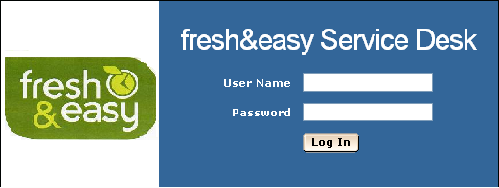

We will create a new Change Request
Click on File
Select New Request For Change

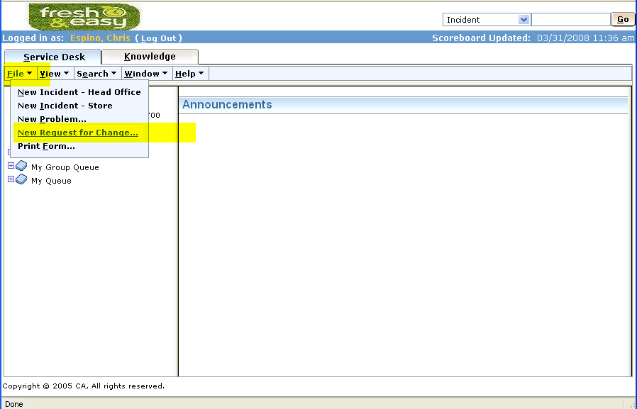

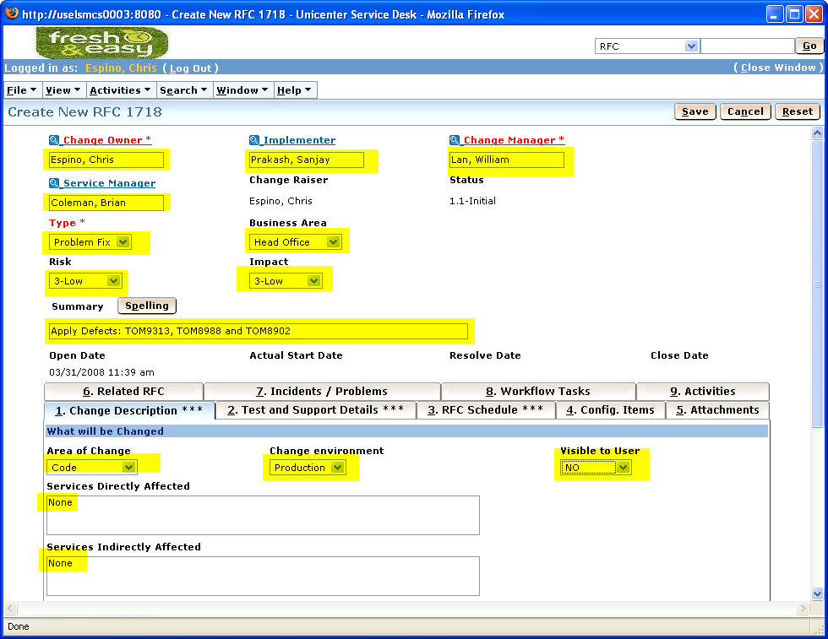

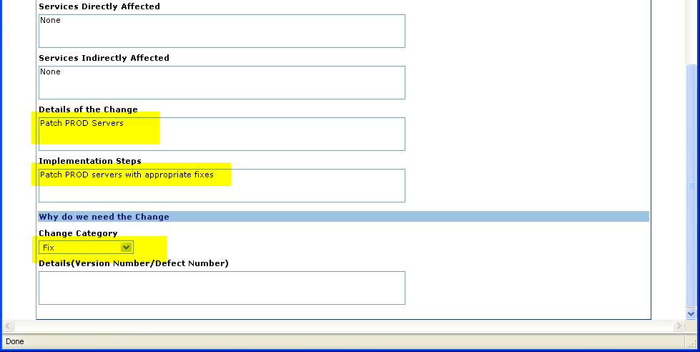

Ensure all the fields are populated

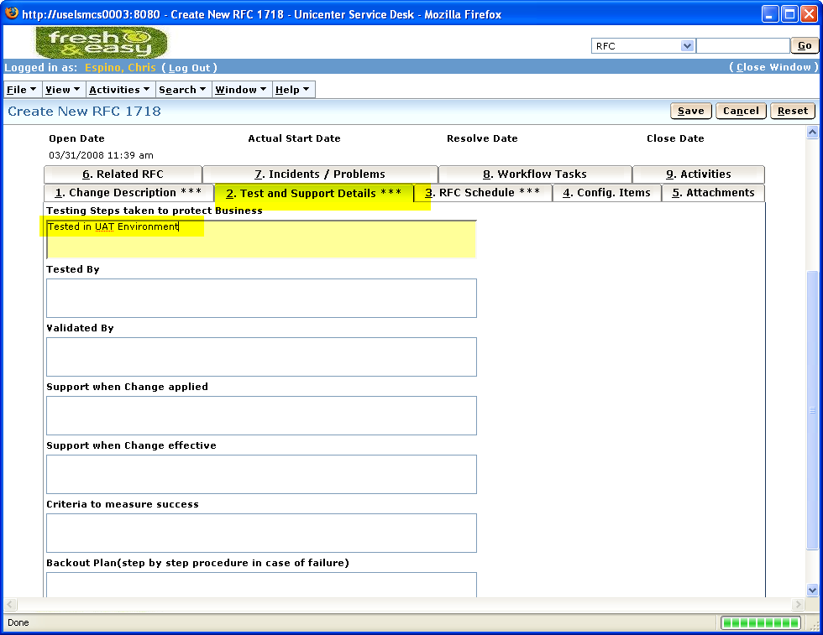

IN the Test and Support Details tab
Populate the required fields

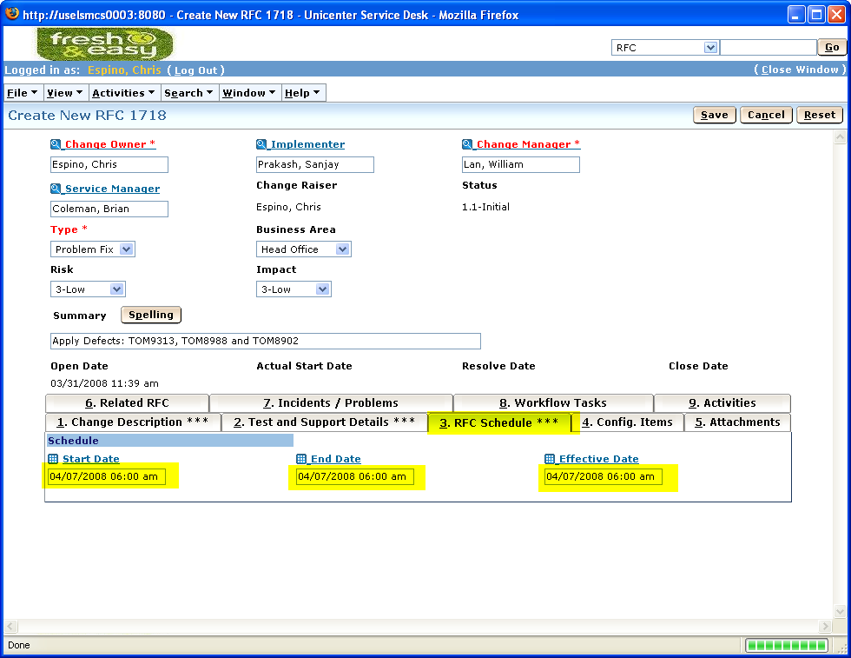

In the RFC Schedule Tab
Ensure all fields are populated

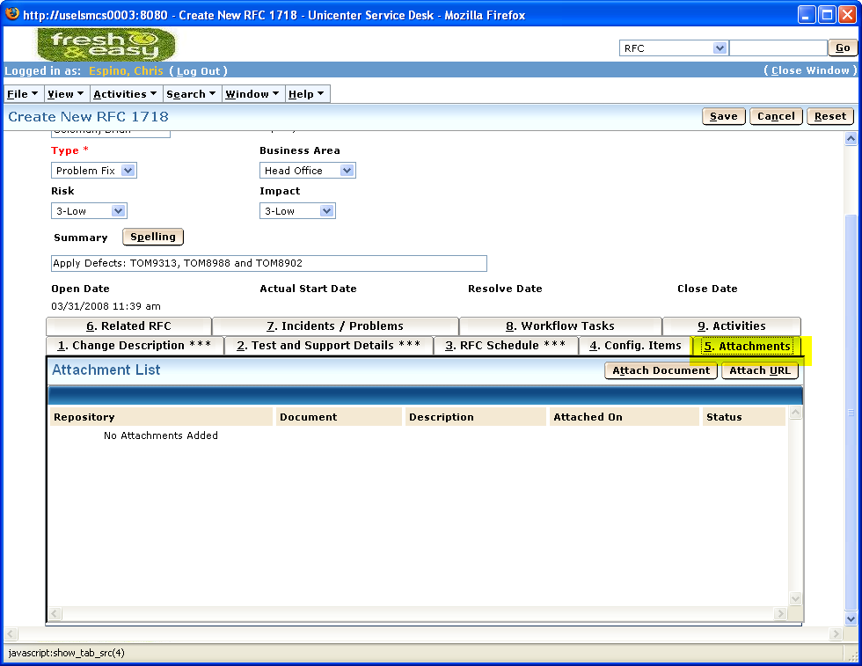

Attachments Tab

Once you’re done click SAVE on the Right Top Corner

